Huntington’s Disease  ”At-Risk” Preparation √ Checklist  By Phil Hardt | 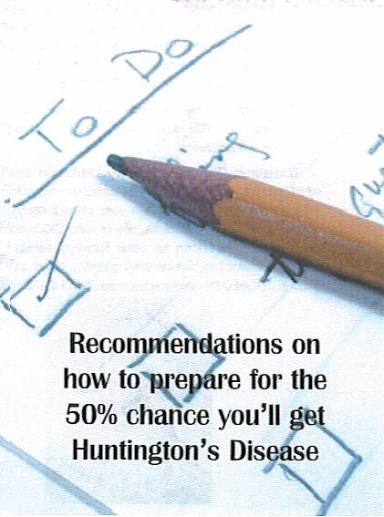

Introduction

Many people who are “at-risk” frequently ask for recommendations on how to prepare for the chance they will become symptomatic with Huntington’s Disease (HD). The simple answer is

“Prepare like you are going to get it and then live like you won’t!”

By doing this, you are being proactive in minimizing the financial and emotional damage that can result from HD if preparation isn’t adequate. Once HD begins, it can adversely affect insight, emotions and judgment. Of course you wish you were not at risk but you are, so look it right in the face!
You can no longer bury your head in the sand and hope for a better day — YOU must take responsibility for that day NOW, for yourself and for your loved ones! | 
The purpose of this brochure is to give you common-sense steps to protect you and your family, just in case…..

Insurance

√ Sign up for Short-term disability (STD) and Long-term disability (LTD) insurance through your employer. Most companies offer open enrollment periods when coverage can be added or changed without question. For LTD, opt for the highest available percentage. Then, if you can no longer work because of any disability including HD, you’ll continue to receive a percentage of your salary based on that option. | 

√ Sign up for Long-term care insurance (LTCI), which protects you in case the need arises for extended nursing or in-home care. The sooner this insurance is purchase, the less expensive your premium will be.

√ Through your employer, sign up for the maximum amount of life insurance available without having to show proof of insurability. Add two riders onto your life insurance policy (usually at no additional cost):

- Children’s Rider: Provides $10,000 coverage per child, which they can convert at age 18 into their own $50,000 policy without showing proof of insurability. If you should become HD positive before this is done, your children may not be able to get their own policy.

- Accelerated Benefits Rider: Allows use of up to 50% of the face value of your policy to pay for nursing home care, if necessary.

- Obtain a Personal Liability Umbrella insurance policy, which provide additional personal liability coverage in increments of $1 million dollars and supplements your present homeowner’s or auto policies. Cost is minimal, usually around $300/year. This will add additional protection to your family’s assets if your loved one doesn’t want to give up driving and/or has a serious accident, or gets into a fight with someone because of an HD-affected rage attack.

Education

√ Obtain as much education and/or marketable trade skills as possible so that you can work for a company that offers Group benefits. Group benefits are usually less expensive and you do not have to show “proof of insurability” when signing up for the policy.

√ Encourage your spouse or partner to complete their education. If something happens to you and they must work, s/he will be able to find a better-paying job because they will
be well-prepared to do so.

√ Immediately educate yourself about the variability of HD symptoms, especially the “softer” signs, which are the emotional, behavioral, and cognitive changes such as: depression, paranoia, impulsivity, rage, withdrawal, loss of consequential thinking, emotional blunting, false sense of superiority, and loss of social inhibition. You and your family must understand these symptoms so that you can recognize and cope with them positively. Your extended family members should be included, as well; share your knowledge and understanding with them so that they may benefit, too.

Employment

√ Stay with your current employer if you are already tenured or are close to reaching your 10-year anniversary. With most companies, if you have 10 years of service prior t becoming disabled AND you are covered by STD and LTD, your current medical, dental, vision and mental health benefits will continue, at the current rate you are paying, for as long as you are disabled. Additionally, you may continue accruing service time toward retirement during your disability.

√ If self-employed, on the other hand, you may find these insurance less affordable and that they may require “proof of insurability.” If it’s indicated on the application that there is a person with HD in your family, you will likely be declined or offered a policy wit extremely expensive monthly premiums. If, on the other hand, false statements are made on an application and later discovered, the insurer can void your coverage. You may need to ‘bite the bullet’ and work for a large corporation in order to care for your family’s needs.

Financial/Medical/Legal

√ Get your financial affairs in order by creating a Last Will and Testament, a Family Trust (to avoid money being held in probate for the year or longer after your death), and a Durable Power of Attorney (to assign the individual who will manage your financial affairs). These are difficult issues; however, they are ones that cannot wait because, once the “softer” signs of HD affect your thought processes, you may not want to complete the necessary steps to protect yourself and your family from financial hardship. Note: A lawyer or legal association can help you determine your state’s document and filing requirements.

√ Get your medical affairs in order by completing a Living Will and Durable Medical Power of Attorney. NOW is the time to make known your personal desires regarding the quality of life you wish to maintain if you become symptomatic. Advise your family regarding issues such as the use of a feeding tube and/or mechanical life supports, and organ donation to benefit others and/or for medical research. | 

If you procrastinate and become less competent and unable to make these decisions for yourself, the law where you live will make them for you. Do not put your family through that! HD-affected emotions like fear, paranoia, lack of trust, loss of forward (or consequential) thinking, and emotional blunting may cause you to not care, or by then you may not see how these decisions will affect your family’s future or yours.

Taking Care of...You!

√ Begin immediately to eliminate stress from your life! Eat nutritiously and maintain a healthy lifestyle. Exercise daily to keep fit and strong. Read, do crossword puzzles and anything else that will challenge your brain in order to keep it sharp and limber.

√ Do not overlook your emotional and spiritual well being, either. The better you feel physically, mentally and spiritually, the easier it will be to cope positively if you inherit HD.

In Summary
√ Starting to do these things now, while your violin still has all of its strings, will help make it so much easier when and if your 4th string snaps and you are forced to continue playing in the concert called “life” with only three! | 
“So, perhaps our task in this shaky, fast changing, bewildering world in which we live is to make music, at first with all that we have, and then, when that is no longer possible, to make music with what we have left.”
~ Jack Riemer, The Houston Chronicle

Resources

Insurance
Health Insurance Organization: www.healthinsurance.org
Affordable Health Insurance: www.insurancequotes4u.com

Education
American Assn. of Adult & Continuing Education: www.aaace.org
Adult Continuing Education: www.gradschools.com

Employment
Monster Jobs: www.monster.com
American Career Executives: www.amcareer.com

Legal
Affordable Legal Help: www.legal-help-usa.org
Legal Aid www.legalmatch.com

Taking Care of You!
American Council for Fitness & Nutrition: www.acfn.org/resources
Stress Less® www.stressless.com

 |   